APPLICATION LOGGING:

This is when you start App from browser.

<http://localhost:8092>

<https://stackoverflow.com/questions/35038242/asp-net-5-core-rc1-how-to-log-to-file-rolling-file-logging-dnx-core-5-comp>

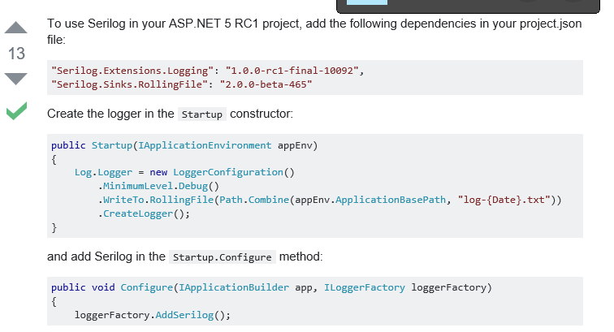

My CODE:

My CODE:

//https://stackoverflow.com/questions/35038242/asp-net-5-core-rc1-how-to-log-to-file-rolling-file-logging-dnx-core-5-comp

string File = "logs/log-{Date}.txt";

if (env.IsDevelopment())

{

Log.Logger = new LoggerConfiguration()

.MinimumLevel.Debug()

.WriteTo.RollingFile(Path.Combine(env.WebRootPath, File))

.CreateLogger();

}

else

{

Log.Logger = new LoggerConfiguration()

.MinimumLevel.Information()

.WriteTo.RollingFile(Path.Combine(env.WebRootPath, File))

.CreateLogger();

}

The logs directory must be created Manually if you want the messages.

It is created in the publish target’s wwwroot directory

If you publish ’debug’ the logs are created in the directory:

C:\websites\Debug\wwwroot\logs